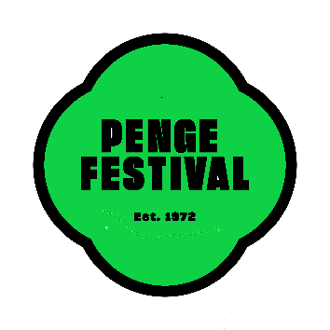
PENGE IN BLOOM 2026 - ENTRY FORM

Please complete the following, indicating which category(s) you would like to enter:

Name:
Address:
Contact Tele. No:
Category(s)
Email Address:

Categories:

1. Best Front Garden Display (Appeal and overall presentation)
Focus on: creativity, colour, design, and how it enhances the street.
2. Best Back Garden Sanctuary (Private Garden, space of any size)
Focus on: Urban wildlife, layout, planting variety, atmosphere, and personal style.
3. Best Container & Hanging Basket (Pot, trough, window box, and basket)
Focus on: impact, colour combinations, creativity in small spaces.
4. Best Community or Shared Garden Space (Schools, churches, clubs, residential blocks, volunteer groups)
Focus on: teamwork, accessibility, benefit to the community.
5. Best Allotment Plot or Kitchen Garden (Flowers, fruit, vegetables, or a mix)
Focus on: productivity, planting skill, sustainability, and presentation.
All categories have an additional score for sustainability, e.g., use of reclaimed, recycled, renewed materials.
Entrants can enter as many categories as they want but can only win one category.

Rules of Entry

Penge in Bloom is an amateur community gardening competition which is designed to help transform Penge and Anerley into a better and more attractive place to live. Entries are encouraged from businesses and residents whose homes, gardens, allotments, or creative space, fall within the Penge and Anerley area.

This year we have partnered with Penge East Community Association (PECA) and their Penge Green Gala Event to be held on 20 June 2026.

Entries may be submitted at any time during the period 10 April to 30 May 2026 to pengepartners@hotmail.com

Judging will take place from 1 June – 30 June 2026 and the results will be published in July.
The Awards’ Presentation event will take place during July at Penge East Recreational Ground.

Award winners should be prepared to allow their photographs to be used for publicity purposes on various local websites on the understanding that neither their names nor addresses are disclosed.

