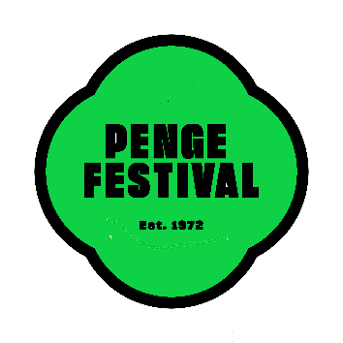
PENGE ALLOTMENTS IN BLOOM 2024
ENTRY FORM

Please complete the following, indicating which category(s) you would like to enter:

Name:
Address:
Contact Tele. No:
Category(s)
Email Address:
CATEGORIES:
1. Best Fruit and Vegetables
2. Best Wildlife and Nature
3. Best Reclaim, Reuse, Recycle
Entrants can enter as many categories as they want but can only win 1 category.

RULES OF ENTRY
Penge in Bloom is a community gardening competition which is designed to help transform Penge and Anerley into a better and more attractive place to live. Entries are encouraged from businesses and all residents whose homes, gardens, allotments, or creative space, fall within the Penge and Anerley area.

Entries may be submitted at any time during the period 1 April to 31 May 2024.

Judging will take place from 1 June – 29 June 2024 and the results will be published in July.
The Awards’ Presentation event will take place on a date yet to be decided at Alexandra Nurseries.

Award winners should be prepared to allow their photographs to be used for publicity purposes on various websites and in local newspapers etc. on the understanding that neither their names nor exact addresses are disclosed.

Please e-mail your completed Entry Form pengepartners@hotmail.com

