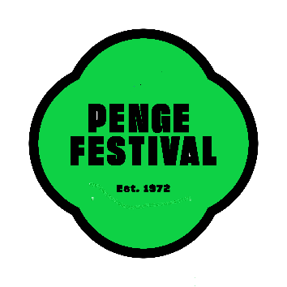
PENGE IN BLOOM 2022
ENTRY FORM

Please complete the following, indicating which category(s) you would like to enter:

Name:
Address:
Contact Tele. No:
Category(s)
Email Address:
CATEGORIES:
1. Jubilee themed, e.g., Queens 70th year
2. Best Front Garden, Space, Display
3. Best Back Garden, Space, Display
4. Most striking Display of Pots, Troughs and/Hanging Baskets
5. Display, creation, baskets, or planters, shop window
All categories have an additional score for Sustainability, e.g., use of reclaimed, recycled, renewed materials.
Entrants can enter as many categories as they want but can only win 1 category.

RULES OF ENTRY
Penge in Bloom is a community gardening competition which is designed to help transform Penge and Anerley into a better and more attractive place to live. Entries are encouraged from businesses and all residents whose homes, gardens, allotments, or creative space, fall within the Penge and Anerley area.

Entries may be submitted at any time during the period 1 June to 30 June 2022.

Judging will take place during the first week of July 2022 and the results will be published the following week.
The Awards’ Presentation event will take place on a date yet to be decided at Alexandra Nurseries.

Award winners should be prepared to allow their photographs to be used for publicity purposes on various websites and in local newspapers etc. on the understanding that neither their names nor exact addresses are disclosed.

Please e-mail your completed Entry Form pengepartners@hotmail.com
or mail to:

Penge in Bloom 2022
c/o

